1 Purpose 1
2 Related Documentation 1
3 Hardware Schematic 1
3.1 PIC Controller Board 1
3.2 H-Bridge Driver board 1
4 XYZ Stepper Firmware CODE 1
4.1 Firmware on Power up: main.c 1
4.2 Serial Communications: ser.c (user program guide) 1
4.3 Instrument Status: system_status.c 1
5 LabView Instrument drivers 1
5.1 XYZ Stepper- Initialize.vi 1
5.2 XYZ Stepper- Write Drive Mode.vi 1
5.3 XYZ Stepper- Abort.vi 1
5.4 XYZ Stepper- Clear Limit Status.vi 1
5.5 XYZ Stepper- Clear System Status.vi 1
5.6 XYZ Stepper- Read Limit Status.vi 1
5.7 XYZ Stepper- Read System Status.vi 1
5.8 XYZ Stepper- Write MAX Speed.vi 1
5.9 XYZ Stepper- Write MIN Speed.vi 1
5.10 XYZ Stepper- Write Vref.vi 1
5.11 XYZ Stepper- Read Vref.vi 1
5.12 XYZ Stepper- Send HOME.vi 1
5.13 XYZ Stepper- Send to Position.vi 1
5.14 XYZ Stepper- Write Drive Location.vi 2
5.15 XYZ Stepper- Read Position.vi 2
5.16 PIC - COM Read.vi 2
5.17 XYZ Stepper- Instrument Address.vi 2

1 Purpose

The purpose of this instrument is to allow for the control of a mechanical fixture that was designed to provide 3D physical placement by way of automation. This document describes the electrical hardware, firmware and instrument drivers used to control the X, Y and Z axis stepper motor drivers used on this mechanical fixture.

This instrument allows the stepper motors to be controlled by way of three different drive modes that are configurable by way of a serial interface. The modes are: Half Step, Normal (also called two-phase-on) and Wave Drive (also called one-phase-on). In Half Step mode, the HALF/FULL signal from the processor will remain HIGH for the duration of the Step drive. All step drives will start with the translator placed in its HOME position by driving the RESET line low. The translator state is required to provide the other two drive modes. HOME is considered to be state ‘1’ or an ODD numbered state. A rising edge on STEP advances the translator to its next state. When driving clockwise, the next state is ‘2’ or EVEN. If the drive mode selected is Normal, HALF/FULL will be LOW when the translator is in an ODD state and will be HIGH when the translator is in an EVEN state. When Wave Drive is selected, the state of HALF/FULL is the opposite of Normal drive so HALF/FULL is HIGH when the translator is in an ODD state and LOW when the state is EVEN. The following diagram shows the relationship between the STEP and HALF/FULL signals for the drive modes described.

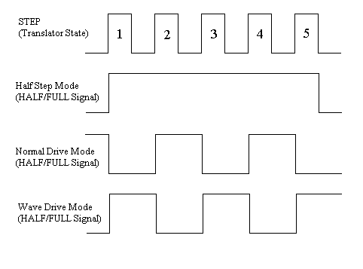
Figure 1: Drive Mode State

The axis location in the firmware of this instrument is always with respect to an axis ‘0’ position. In most cases, this is the HOME limit switch position and is designated by the drive being driven counter clockwise until the HOME limit switch is detected. This location is position ‘0’ for the axis and all other locations will be positive with respect to this location. Other locations can be designated in firmware to be location ‘0’ by a serial port function but firmware will not support negative direction step values. Software can be written on top of the firmware definition to allow other position schemes. Please note that the send home serial commands always looks for the HOME limit switch to be detected. If a ‘0’ location other than the HOME limit switch location is required, simply use the send to position command. Directing and reading an axis stepper location is always done in ‘steps from 0’. A step occurs every time there is a transition on the STEP signal line from LOW to HIGH. The Drive Mode selected and the screw being driven determines the measured distance of travel so software can be used to provide the conversion. This firmware allows for the most flexibility of use by using the methods described to handle different stepper motor and screw combination without having to re-write firmware.

The speed at which the stepper moves is called the Step Frequency. The step frequency is the frequency of the STEP signal. Two modes are available. In FIXED frequency mode, the axis min (or slow) frequency is used and remains constant until the step location is reached. In RAMP mode, the step begins at the min or slow frequency and increases until the max (or fast) frequency is reached. It will remain at the max frequency until the step location is reached. The frequencies used are dependant upon the motor and torque requirements of the axis selected. The serial interface to the instrument allows these frequencies and modes to be changed in ram.

2 Related Documentation
The following documents were used to create and should be referenced when reviewing this document:

1. PIC16(L)F1933 Data Sheet 28-Pin Flash Microcontrollers
2. Maxim +5V-Powered, Multichannel RS-232 Drivers/Receivers
3. IR2104 Half Bridge Driver
4. IRFZ44 Power MOSFET
5. L297 Stepper Motor Controller
6. LM317 3-Terminal Adjustable Regulator
7. LM358 Low Power Dual Operational Amplifier
8. HI-TECH Software PICC Lite Ansi C Compiler
9. MPLAB IDE v8.56
10. PICKit 2 v2.61
11. XYZ_StepperControl.mcw (This projects workspace.)

3 Hardware Schematic
There are (primarily) three circuit boards used in the design of this controller. The PIC Controller board contains the PIC 16F1933 microcontroller as well as the RS-232 serial interface. This board was hand wired do to the fast development of this instrument. This method allowed for I/O changes (if needed) as the instrument evolved.

The other two boards were laid-out to speed up the assembly of this first proto type. They are Dual H-Bridge Driver boards and the difference between them is simply two components used for the ‘chopper’ of the L297. The L297 is a translator that generates the stepper motor phase sequences. The ‘chopper’ is a resistor and capacitor used to regulate current in the motor windings. This resistor and capacitor is populated on the X1 drive board and provides a SYNC to the other three (X2, Y and Z). By synchronizing the chopper frequencies, ground noise is suppressed.

The PIC Controller board will tell the driver boards how to step and provide the reference voltage for the chopper circuit.

3.1 PIC Controller Board

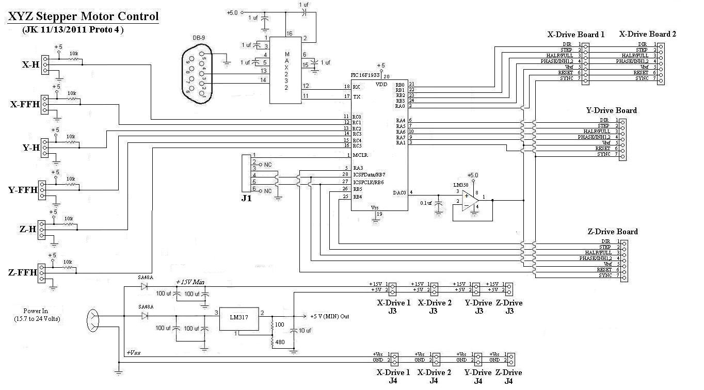
PIC Controller Board

The Half-bridge Driver on the Drive Boards has a maximum limit of 25 volts. The power supply being used to provide power to this instrument was not designed specifically for this application but prevented us from having to spend any real time designing one. Currently, this power supply limits the current capabilities of the H-Bridge Driver boards. This current limitation required us to tie the L297 ENABLE lines to the RESET line control. This provided the ability to disable the hold currents of the stepper motors freeing current up to be used to drive the axis. This under current from the supply also required us to add supply protection to the processor and Driver boards to prevent resets during motor startup current states. The LM317 is an adjustable regulator set to ~ 6.5 Volts. The minimum supply voltage of the l397 is 4.75 volts so a 5 volt regulator is not being used.

X-H, Y-H and Z-H are hall-effect switch used to indicate HOME position. This is considered position 0 for a given axis. All other locations are a positive value as far as firmware is concerned. This may not be desirable but signed integers in firmware is a waste of programmable space when the software (instrument driver) can easily manage it by reading the current location and defining it as HOME. Positive or negative values can be executed with respect to the software defined HOME location. These inputs are wired to the Schmitt-triggered (digital) inputs of the PIC. The inputs are tri-state and are configured upon power up.

X-FFH, Y-FFH and Z-FFH are hall-effect switches used to indicate Far From Home or the location furthest from position 0. They are also wired to Schmitt – triggered inputs of the PIC. Again, they are configured upon power-up. De-bouncing capabilities are initiated but are not required with these sensors. This feature is also available on the HOME indicators. De-bouncing is done simply by reading the digital input a series of times. The reads take place every 125 nSec (one instruction cycle) during the drive when not interrupted by the interrupt service routine. The interrupt service routines were not done in assembly or by way of macros to assist in keeping this firmware ‘easy’ to read but do to the slow nature of the step frequencies, making the service routines execute faster is not necessary.

DACOUT provides the reference voltage for the chopper circuit of the L297. This reference is buffered due to its limited drive current capability. A fixed voltage reference of 1.024 V is used to provide this voltage because it is regulated and is less likely to transfer supply ‘bounce’ to the L297 chopper. This DAQOUT also has 5 bits of resolution so providing a range closer to the values being used provides better resolution. The reference used is dependant upon the motor and torque needs of the drive. This value requires a trim to determine the correct setting. Currently, this trim is written to the flash. However, this value can be modified in RAM by way of the available drivers. This is allowed because device under test loads may require a need for this capability in the future. The following is how a starting value for this reference voltage can be calculated:

VREF = MOTOR CURRENT * 0.2 Ohms

Drive torque capabilities are calculated by way of the stepper motor selected and are contained within a torque curve with respect to stepper drive frequency such as the following:

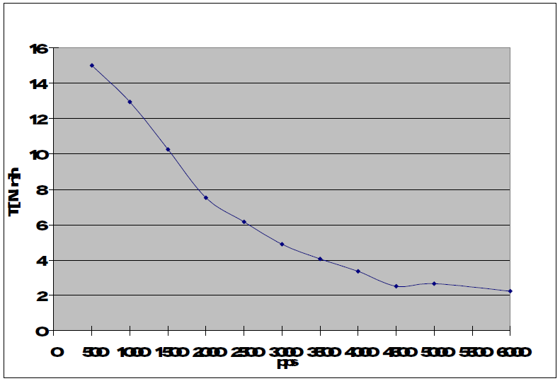
General Torque Curve

The Drive Board connectors are the interface to the L297. X has two motors driving the axis driven in parallel. Other than the reference used for the chopper circuits, all PIC connections are digital out. The STEP signal is used to provide the frequency and count of moves to the translator. This STEP is generated using timers of the PIC. Timer2 is used for the X drive. Timer4 is the Y and Timer6 is the Z drive. These timers are configured upon power up to have an 8 uSec resolution (8 bit). The STEP takes place every low to high transition so a 50% duty cycle is used and is executed by way of an interrupt. The calculation is as follows:

TRANSITION = 125000/(STEPPER FREQUENCY * 2.0)

Default starting frequencies have been written to Flash but can be adjusted in RAM by way of the provided instrument drivers. This frequency can be adjusted while the stepper is executing.

3.2 H-Bridge Driver board

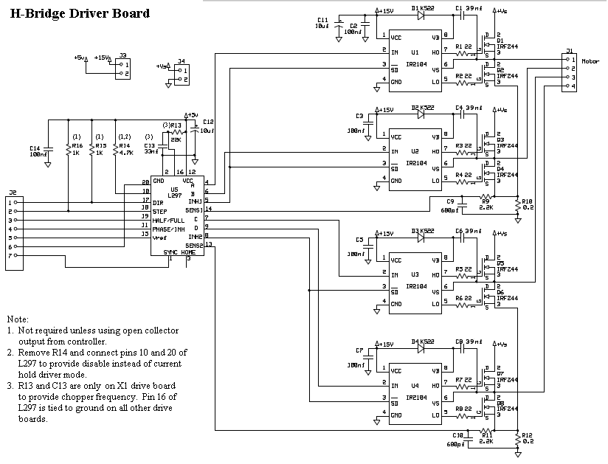
H-Bridge Driver Board

There are four of these boards in this system. These boards provide the interface between the logic provided by the PIC controller board and the actual stepper motors. Two configurations of the H-Bridge Board are being used. X1 drive contains the chopper control. Sync provides this frequency control to the other three boards. This is done to minimize ground noise (bounce).

4 XYZ Stepper Firmware CODE

The purpose of this section is to describe this device’s firmware functions as they relate to this application and to briefly describe the firmware architecture.
4.1 Firmware on Power up: main.c
Main.c contains three important firmware architecture pieces. First, the PIC configuration word(s) are defined here. The configuration words setup the 16F1933 oscillator and memory protection options. For this application, FOSC is set to run at 32 MHz.

The main entry point to the code is also here. On power up, this configures the tri-state port inputs and outputs for this application, the serial interface, sets the fixed voltage reference value (to 1.024) used with DACOUT to provide the chopper threshold and enables the interrupts for the serial interface. This main entry points ends with a while statement where the firmware will sit and wait for a receive interrupt command instructing the instrument to do something.

The third item contained in this source code file is the interrupt service routine. There is only one interrupt vector in this processor. When an interrupt occurs, firmware will jump to this address and execute the code located here. Two things have to be established before this jump will occur. First, the interrupt capability needs to be enabled. Other then the serial interface, functions called will enable the interrupts they need when they require them. Second, the event has to take place. A flag associated with the event is typically used to determine what portion of the interrupt service routine will execute. When the service routine completes, firmware will return to the location it was prior to the jump.
4.2 Serial Communications: ser.c (user program guide)

The ENHANCED UNIVERSAL SYNCHRONOUS ASYNCHRONOUS RECEIVER
TRANSMITTER (EUSART) is used to provide a user interface to the functions available. Because functions are acted on based on serial communications, to speed up the processing of the request it is important to keep the received message as short a possible. SPBRG is set to 0x19 setting the baud rate ~19200 (1923). Resetting the interface requires cycling power on the device. Instrument drivers can be configured to handle time outs if the interface fails to respond. However, this should not be an issue when functions are defined and written appropriately.

The first char in the buffer must contain the message size. The RX Interrupt will use the message size to know when the instruction has been completely captured and Execute can be called. This message size does not include the first char. For example, to read the Limit Status register the command is ‘RL’. The size of the message is 2 chars so rxfifo would contain the following:

rxfifo[0] = 2
rxfifo[1] = ‘R’
rxfifo[2] = ‘L’

The following shows the RX Interrupt. Please note that sending a message to the PIC and forcing this interrupt to execute interrupts other functions from running so ‘polling’ for status via the serial interface should contain delays.

RX Interrupt

if(RCIF)
{
// If an error occured, reset to clear it
if(OERR)
{
CREN = 0;
CREN = 1;
}
// The first value received will contain the number
// of chars in the message
if( index == 0)
RX_Size = (int)RCREG;

// Capture the second Char to the message size in the
// rxfifo buffer
if(index > 0 && index <= RX_Size)
rxfifo[index-1] = RCREG;

index++;

// If we got all the chars, reset the index for the next
// RX Interrupt and execute the command we received
if(index > RX_Size)
{
index = 0;
Execute();
}
}

The following instructions are currently supported:

Note:
The first byte sent is the message size in decimal. The receive interrupt routine will remove this message size byte prior to this call being made:

'1I' - Initialize, set Drive Mode and send XYZ HOME (see initialize.c)

'2AA' - Abort all (XYZ) drive (see abort.c)
'2AX' - Abort X Drive (see abort.c)
'2AY' - Abort Y Drive (see abort.c)
'2AZ' - Abort Y Drive (see abort.c)

'5SNX**' - Send X to new '**' step location, where ** = 0 to 0xFFFF steps (see drive_motor.c)
'5SNY**' - Send Y to new '**' step location, where ** = 0 to 0xFFFF steps (see drive_motor.c)
'5SNZ**' - Send Z to new '**' step location, where ** = 0 to 0xFFFF steps (see drive_motor.c)

'3SHA' - Send All (XYZ) to HOME position (see drive_home.c)
'3SHX' - Send X to HOME position (see drive_home.c)
'3SHY' - Send Y to HOME position (see drive_home.c)
'3SHZ' - Send Z to HOME position (see drive_home.c)

'4WVX*' - Write X-Drive Vref, where X = 0 to 31 dec and is a ratio of 1.024 (see vref.c)
'4WVY*' - Write Y-Drive Vref, where X = 0 to 31 dec and is a ratio of 1.024 (see vref.c)
'4WVZ*' - Write Z-Drive Vref, where X = 0 to 31 dec and is a ratio of 1.024 (see vref.c)

'8WD012233'- Write Drive Mode where 0 = the channel (X,Y or Z) , 1 = DRIVE_MODE
register, 22 = ramp_step register and 33 = frequency change in the step.

'5WFX**' - Write X_max_speed to new '**' frequency, where ** = 0 to 0xFFFF Hz (see drive_timer.c)
'5WFY**' - Write Y_max_speed to new '**' frequency, where ** = 0 to 0xFFFF Hz (see drive_timer.c)
'5WFZ**' - Write Z_max_speed to new '**' frequency, where ** = 0 to 0xFFFF Hz (see drive_timer.c)
'5WSX**' - Write X_min_speed to new '**' frequency, where ** = 0 to 0xFFFF Hz (see drive_timer.c)
'5WSY**' - Write Y_min_speed to new '**' frequency, where ** = 0 to 0xFFFF Hz (see drive_timer.c)
'5WSZ**' - Write Z_min_speed to new '**' frequency, where ** = 0 to 0xFFFF Hz (see drive_timer.c)

'2RS' - Read System Status (see system_status.c)
'2RL' - Read Limit Status (see system_status.c)
'3RVX' - Read X-Drive Vref (see vref.c)
‘3RVY' - Read Y-Drive Vref (see vref.c)
'3RVZ' - Read Z-Drive Vref (see vref.c)
'3RPX' - Read Position of X with respect to HOME (see drive_start.c)
'3RPY' - Read Position of Y with respect to HOME (see drive_start.c)
'3RPZ' - Read Position of Z with respect to HOME (see drive_start.c)

'2CS' - Clear System Status (see system_status.c)
'2CL' - Clear Limit Status (see system_status.c)

The system_status register will contain error information concerning the status of a received command. See 4.3 Instrument Status for details.

4.3 Instrument Status: system_status.c
This file contains control and definition of two status and error information registers. It contains the serial interface functions used to read and clear these registers. The two register are: system_status and limit_status. If you look through the projects firmware you may notice that a bit definition may have been easier to use in a lot of locations vs. that of an unsigned char (8 bit) value. This choice is driven by a tool choice. The free Hi-Tech C firmware simulation environment does not allow easy access to bit definitions outside of the slow and cumbersome ‘Watch Variable’ capabilities of that tool. Defining a bit that references another bit in an 8 bit register takes program space so you learn to live with it.

system_status register

Bits of the following register will contain System Status Information as follows:

Errors:
0bXXXX XXX1 System Error
0bXXXX XX1Y Invalid Serial Command
0bXXXX X1XY VREF value Error
0bXXXX 1XXY Period value Error
Status:
0bXXX1 XXXX X-Drive Running
0bXX1X XXXX Y-Drive Running
0bX1XX XXXX Z-Drive Running
0bYXXX XXXX Not Used

limit_status register

Bits of the following register will contain information of the Limit Switch status. This register only contains status information for these switches and is defined as follows:

0bXXXX XXX1 X Home Status (RC0, X-H)
0bXXXX XX1X X Far From Home (RC1, X-FFH)
0bXXXX X1XX Y Home Status (RC2, Y-H)
0bXXXX 1XXX Y Far From Home (RC3, Y-FFH)
0bXXX1 XXXX Z Home Status (RC4, Z-H)
0bXX1X XXXX Z Far From Home (RC5, Z-FFH)
0bXYXX XXXX Not Used
0bYXXX XXXX Not Used
5 LabView Instrument drivers
The following LabView instrument drivers have been written to access features of this instrument.

5.1 XYZ Stepper- Initialize.vi
'1I' is sent to initialize the XYZ Stepper Motor Test fixture. The TX Buffer will be cleared prior to this being sent to clear out any old data. All of the motor drive variables (drive modes, frequencies and reference voltages) will be returned to their POR conditions. This reset will return the X, Y and Z motors to their HOME position. The serial interface will not be changed. If successful, 'XYZ*' will be returned where * is the PIC Firmware version.

(see initialize.c)

Connector Pane
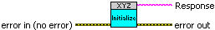

Front Panel
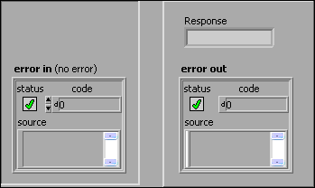

5.2 XYZ Stepper- Write Drive Mode.vi
'8WD012233'- Write Drive Mode where 0 = the channel (X,Y or Z) , 1 = DRIVE_MODE register, 22 = ramp_step register and 33 = frequency change in the step. The DRIVE_MODE register is decoded as:

0bXXXX XXX1 = HALF STEP Mode
0bXXXX XX10 = WAVE DRIVE or One Phase On Mode
0bXXXX X100 = NORMAL Drive or Two Phase On Mode
0bXXXX 1XXX = NA
0bXXX1 XXXX = RAMP Enable Bit
0bXX1X XXXX = NA
0bX1XX XXXX = NA
0b1XXX XXXX = Translator ODD or EVEN State Flag

HALF Step Mode: HALF/FULL digital control line is always HIGH
WAVE DRIVE: HALF/FULL digital control is LOW when translator is at an even state
NORMAL: HALF/FULL digital control is LOW when translator is at an odd state

HOME position is 1 or an odd state. All drive starts occur from the HOME state.

A RAMP can occur when the state is enabled (0x10). The min_frequency for the channel is always the start of the ramp and will be the only frequency used if RAMP is disabled. The 'RAMP on Step' control sets the number of steps that will occur before the step frequency is increased. 'Frequency of Step' controls the increase. The increase will continue until the step frequency matches the max_speed for the channel.

(see drive_mode.c)

Connector Pane
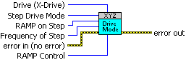

Front Panel
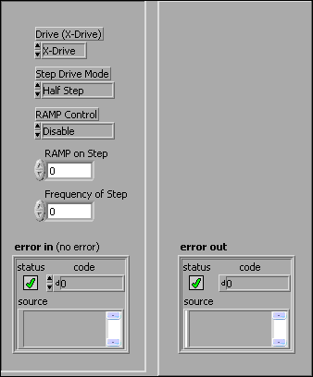
5.3 XYZ Stepper- Abort.vi
'2A*'- Abort Drive where * is the channel(s) being stopped as follows:

'A' - All Drives (XYZ)
'X' - X-Drive
'Y' - Y-Drive
'Z' - Z-Drive

Nothing will be returned.

(see abort.c)

Connector Pane
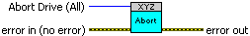

Front Panel
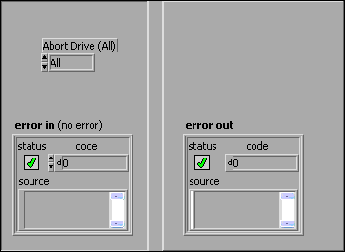

5.4 XYZ Stepper- Clear Limit Status.vi
'2CL'- Clear XYZ Stepper Limit Status will set limit_status to 0b00000000 clearing all limit switch information. Nothing will be returned. The register cleared contains the following information:

Status:
0bXXXX XXX1 X Home Status (RC0, X-H)
0bXXXX XX1X X Far From Home (RC1, X-FFH)
0bXXXX X1XX Y Home Status (RC2, Y-H)
0bXXXX 1XXX Y Far From Home (RC3, Y-FFH)
0bXXX1 XXXX Z Home Status (RC4, Z-H)
0bXX1X XXXX Z Far From Home (RC5, Z-FFH)
0bX1XX XXXX Not Used
0b1XXX XXXX Not Used

(see system_status.c)

Connector Pane


Front Panel
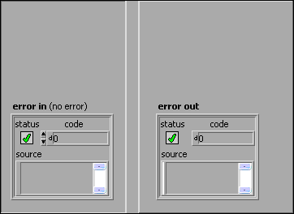

5.5 XYZ Stepper- Clear System Status.vi
'2CS'- Clear XYZ Stepper Status and Error will set system_status to 0b00000000 clearing all status and error information. Nothing will be returned. The register cleared contains the following information:

Errors:
0bXXXX XXX1 System Error
0bXXXX XX1Y Invalid Serial Command
0bXXXX X1XY VREF value Error
0bXXXX 1XXY Period value Error
Status:
0bXXX1 XXXX X-Drive Running
0bXX1X XXXX Y-Drive Running
0bX1XX XXXX Z-Drive Running
0b1XXX XXXX Not Used

(see system_status.c)

Connector Pane


Front Panel

5.6 XYZ Stepper- Read Limit Status.vi
'2RL'- Read the Limit Switch Status register. If the switch indicated by the Limit control is set, display a true condition. The raw limit_status code will always be returned. The limit_status register is decoded as follows:

Status:
0bXXXX XXX1 X Home Status (RC0, X-H)
0bXXXX XX1X X Far From Home (RC1, X-FFH)
0bXXXX X1XX Y Home Status (RC2, Y-H)
0bXXXX 1XXX Y Far From Home (RC3, Y-FFH)
0bXXX1 XXXX Z Home Status (RC4, Z-H)
0bXX1X XXXX Z Far From Home (RC5, Z-FFH)
0bX1XX XXXX Not Used
0b1XXX XXXX Not Used

(see system_status.c)

Connector Pane
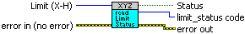

Front Panel
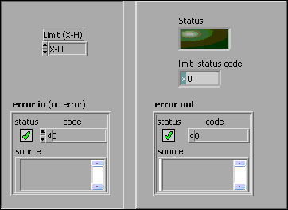

5.7 XYZ Stepper- Read System Status.vi
'2RS'- Read the System Status and error register. This will check the run status bits and the error bit to report if the mode is running. If the error bit is set, the boolean will state the mode is not running but an error will not be reported. This register is decoded as follows:

Errors:
0bXXXX XXX1 System Error
0bXXXX XX1Y Invalid Serial Command
0bXXXX X1XY VREF value Error
0bXXXX 1XXY Period value Error
Status:
0bXXX1 XXXX X-Drive Running
0bXX1X XXXX Y-Drive Running
0bX1XX XXXX Z-Drive Running
0b1XXX XXXX Not Used

(see system_status.c)

Connector Pane
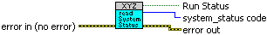

Front Panel
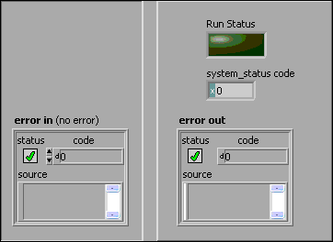

5.8 XYZ Stepper- Write MAX Speed.vi
'5WFX**' is the Write Fast (Max) Speed of the selected drive command. This frequency selection is used as a limit control when the RAMP drive mode is enabled. The RAMP will step the drive frequency up to this value. The selections available are:

'5WFX**' - Write X_max_speed to new '**' frequency; ** = 0 to 0xFFFF Hz
'5WFY**' - Write Y_max_speed to new '**' frequency; ** = 0 to 0xFFFF Hz
'5WFZ**' - Write Z_max_speed to new '**' frequency; ** = 0 to 0xFFFF Hz

(see drive_timer.c)

Connector Pane
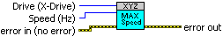

Front Panel
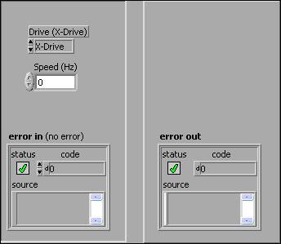

5.9 XYZ Stepper- Write MIN Speed.vi
'5WFX**' is the Write Slow (Min) Speed of the selected drive command. This is always the starting step drive frequency used. The selections available are:

'5WSX**' - Write X_min_speed to new '**' frequency; ** = 0 to 0xFFFF Hz
'5WSY**' - Write Y_min_speed to new '**' frequency; ** = 0 to 0xFFFF Hz
'5WSZ**' - Write Z_min_speed to new '**' frequency; ** = 0 to 0xFFFF Hz

(see drive_timer.c)

Connector Pane
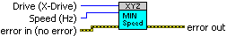

Front Panel

5.10 XYZ Stepper- Write Vref.vi
'4WX*'- Write Drive Channel Vref where X = the channel (X,Y or Z) and * = 0 to 31 DACOUT value that is calculated as follows:

* = 31(Vref Value In/1.024)

The selection commands available are as follows:

'4WVX*' - Write X-Drive Vref, where X = 0 to 31 dec and is a ratio of 1.024
'4WVY*' - Write Y-Drive Vref, where X = 0 to 31 dec and is a ratio of 1.024
'4WVZ*' - Write Z-Drive Vref, where X = 0 to 31 dec and is a ratio of 1.024

The system_status register will be read to verify the new reference value is within the limits of the L297 stepper driver IC.

The reference value used here should be calculated as follows:

Vref Value = (Stepper I Limit) * 0.2 Ohms

(see vref.c)

Connector Pane
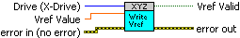

Front Panel
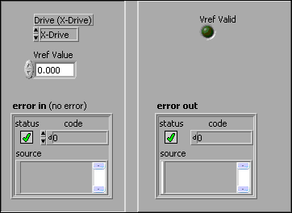

5.11 XYZ Stepper- Read Vref.vi
'3RV*'- Read the current * Drive Vref.

Vref Value = (Value read/31 dec) * 1.024

The selection commands available are as follows:

'3RVX' - Read X-Drive Vref
'3RVY' - Read Y-Drive Vref
'3RVZ' - Read Z-Drive Vref

(see vref.c)

Connector Pane
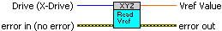

Front Panel
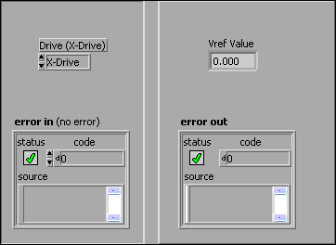
5.12 XYZ Stepper- Send HOME.vi
'3SH*' is the Send HOME command where * is the channel being sent to the home position. The selections available are:

3SHA - All drives (XYZ) are sent HOME
3SHX- X-Drive sent HOME
3SHY- Y-Drive sent HOME
3SHZ- Z-Drive sent HOME

HOME is detected by reading limit_status. Setting the Wait for Completion control to true will allow this send home operation to complete before this VI is exited.

(see drive_home.c)

Connector Pane
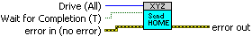

Front Panel
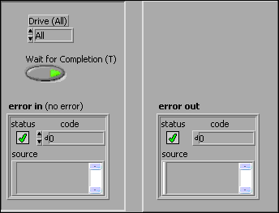

5.13 XYZ Stepper- Send to Position.vi
'5SNX**' is the Send to new position command where X is the drive channel and ** is the position. This position is from 0 to 0xFFFF steps. The selections available are:

'5SNX**' - Send X to new '**' step location, where ** = 0 to 0xFFFF steps
'5SNY**' - Send Y to new '**' step location, where ** = 0 to 0xFFFF steps
'5SNZ**' - Send Z to new '**' step location, where ** = 0 to 0xFFFF steps

Setting the Wait for Completion control to true will allow this operation to complete before exiting this VI and report an error if the drive does not reach the new step position in time.

(see drive_motor.c)

Connector Pane
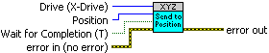

Front Panel
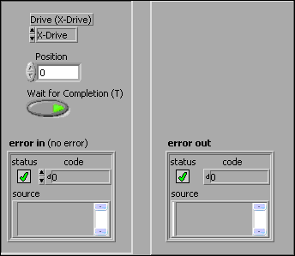

5.14 XYZ Stepper- Write Drive Location.vi
'5WPX**' is the Write drive location command. The selections available are:

'5WPX**' - Write X location; ** = 0 to 0xFFFF Steps
'5WPY**' - Write Y location; ** = 0 to 0xFFFF Steps
'5WPZ**' - Write Z location; ** = 0 to 0xFFFF Steps

(see drive_start.c)

Connector Pane
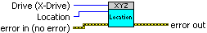

Front Panel
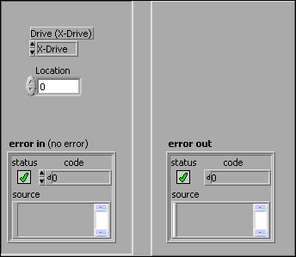

5.15 XYZ Stepper- Read Position.vi
'3RP*'- Read the current * drive position. The position is returned in steps from HOME. The selection commands available are as follows:

'3RPX' - Read Position of X with respect to HOME
'3RPY' - Read Position of Y with respect to HOME
'3RPZ' - Read Position of Z with respect to HOME

(see drive_start.c)

Connector Pane
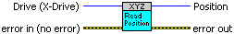

Front Panel
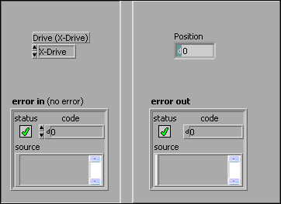

5.16 PIC - COM Read.vi
This VI will read the assigned communication port. When talking with the PIC, the first char return will state the message size. This size char will be removed and the message will be returned.

Connector Pane

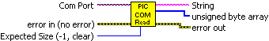

Front Panel

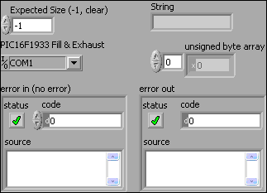

5.17 XYZ Stepper- Instrument Address.vi
Instrument communications port Address for XYZ Stepper Motor Test fixture.

Front Panel

